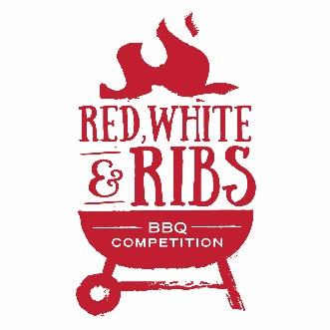
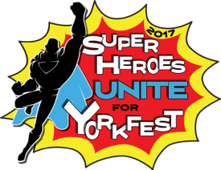
Holthus Convention Center | York, NE
Kids’ Q
Saturday, September 9th, 2017
Team Name:
Age (12 and under only):
Parent Contact:
Address:
Phone Number: Email:
Event Information
This event is in conjunction with Yorkfest and the Nebraska vs. Oregon football game, so we will be creating a community watch party atmosphere (pre-game and game will be shown on big screens inside the facility). Event is open to the public with a ticket fee for public entry. The game is at Oregon and kicks off at 3:30, so we are hoping to have the competition wrapped up by game time. This competition will take place at the conclusion of the adult competition.
- Team entry fee of $5 must be paid by 2:00pm on Saturday, September 9th, 2017.
  - Online Registration and Payment online at yorkchamber.org
    - Select Event, then select Yorkfest
  - Mail-in Registration and check can be sent to 603 N Lincoln Ave, York, NE 68467
- Contestant check-in begins at 1:00pm and ends at 2:00pm.
- Hamburger will be supplied to each registered team upon check-in.
- Grills will be provided for the kids’ contest.
- All teams must be present for the cooks’ meeting at 2:00pm for clarification of contest rules.
- Samples must be ready for judging by 3:30pm.
- The Kids’ Q Champion will receive a trophy.
Waiver of Liability: In consideration of your acceptance of this entry, I waive and release any and all rights and claims against the York Area Chamber of Commerce, the sponsors of the event, and event officials for any injuries suffered by me and/or my child in connection with this event. I further certify I and/or my child are in good enough physical condition to participate in this event.
Signature of Participant: _________________________________________ Date: ________________
Return forms to: Holthus Convention Center | 3130 Holen Ave., York, NE 68467
Phone: 402.363.2675 Email: info@holthusconventioncenter.com

