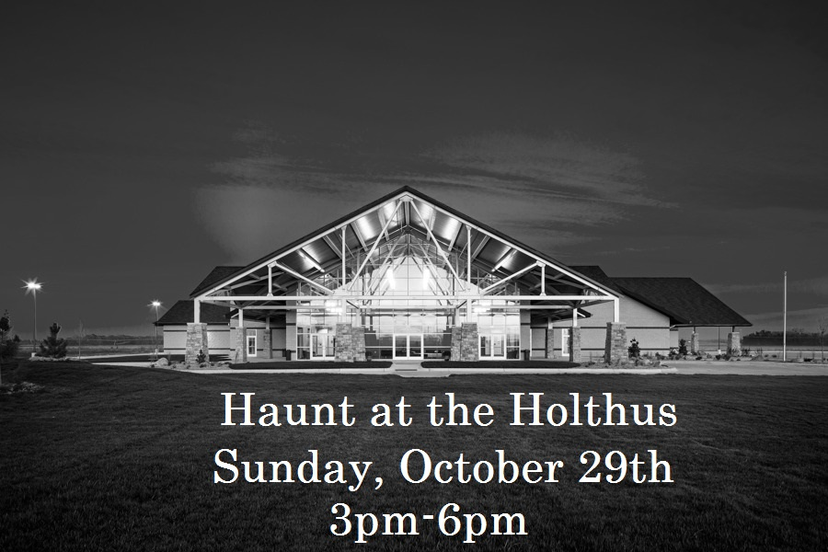
Vendor Setup: 12:30pm-2:00pm
Vendors are required to load/unload on the northeast side of the building near the large overhead door. Please unload as quickly as possible, then park your vehicle on the north side of the building.
Businesses are encouraged to decorate their booths and dress in costume. There will be prizes for the top three displays! However, no one may tape, nail, tack, or otherwise fasten decorations to ceilings, painted surfaces, floors, columns, walls, or windows. One 8 foot table will be provided. Booths will NOT have access to power, so plan accordingly.
In order to keep guest traffic flowing through the Grand Ballroom, we ask that vendors only hand out treats. We expect around 1500 kids to attend again this year. Please make sure to come prepared with enough goodies for everyone.
Business Name: ____________________________________
Address: __________________________________________
Contact Person: ____________________________________
Phone: ___________________________________________
Email: ____________________________________________
Sponsorship: Booth ($35)
Your registration form and check can be mailed to: Holthus Convention Center, 3130 Holen Avenue, York, NE 68467. Or, you may make a credit card payment online at https://holthusconventioncenter.presencehost.net/plan-event/payment.html and email the registration form to info@holthusconventioncenter.com
A vendor map and additional information will be sent out after the registration period has ended.

