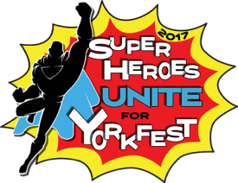
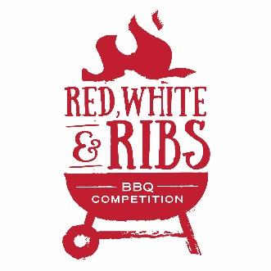
Holthus Convention Center | York, NE
Saturday, September 9th, 2017

Team Name:
Pitboss:
Address:
Phone Number: Email:
Approximate # of racks you are able to cook:
Event Information
This event is in conjunction with Yorkfest and the Nebraska vs. Oregon football game, so we will be creating a community watch party atmosphere (pre-game and game will be shown on big screens inside the facility). Event is open to the public with a ticket fee for public entry. The game is at Oregon and kicks off at 3:30, so we are hoping to have the competition wrapped up by game time so teams are able to begin serving to the public prior to kickoff and throughout the first half of the game.
ALL ALCOHOL MUST BE PURCHASED ON SITE FROM KERRY’S RESTAURANT AND CATERING.
- Team entry fee of $50 must be paid by Monday, August 28th, 2017.
  - Online Registration and Payment online at yorkchamber.org
    - Select Event, then select Yorkfest
  - Mail-in Registration and check can be sent to 603 N Lincoln Ave, York, NE 68467
- Contestant check-in begins at 7:00am and ends at 9:00am.
  - Arrangements for check-in on Friday night can be made upon request.
- Ribs will be supplied to each registered team upon check-in.
- Contestants are to supply their own grill, smoker, utensils, etc.
- All teams must be present for the cooks’ meeting at 9:30am for clarification of contest rules.
- Samples must be ready for judging by 2:00pm. Judging will follow Midwest BBQ Association guidelines.
- We will begin serving the public at 3:00pm.
- Red, White & Ribs Champion receives $750, 2nd Place receives $500, 3rd Place receives $250.
Waiver of Liability: In consideration of your acceptance of this entry, I waive and release any and all rights and claims against the York Area Chamber of Commerce, the sponsors of the event, and event officials for any injuries suffered by me and/or my child in connection with this event. I further certify I and/or my child are in good enough physical condition to participate in this event.
Signature of Participant: _________________________________________ Date: ________________
Return forms to: Holthus Convention Center | 3130 Holen Ave., York, NE 68467
Phone: 402.363.2675 Email: info@holthusconventioncenter.com

